Petersburg Borough 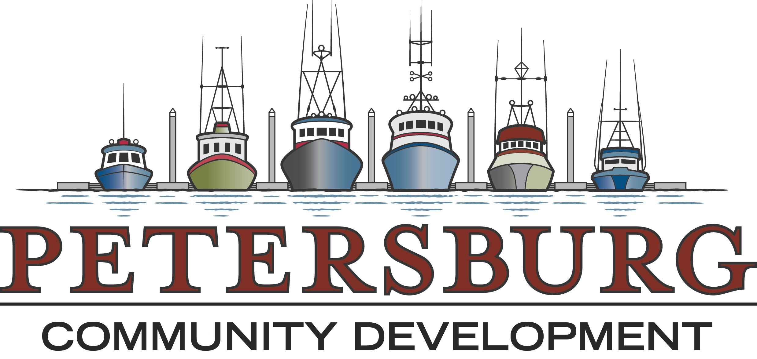
Community & Economic Development
P.O. Box 329 PHONE (907) 772-4533
Petersburg, AK 99833 FAX (907) 772-4876

Application No: ____________________ Date Received: _____________________________
Fee Collected: ______________________ Received By: ______________________________

Ref to Assembly: ____________________ Ordinance No: _____________________________

APPLICATION FOR VACATION OF PUBLIC EASEMENT/LANDS

Petitioner(s): ___________________________ _____________________________________
Address: ______________________________ _____________________________________
Phone Number(s):_______________________ _____________________________________

Petitioners’ Representative (Sub-divider, if any) and/or Registered Engineer or Land Surveyor:
Name(s):_________________________ _____________________________________
Address: _________________________ ____________________________________
Phone Number(s):__________________ _____________________________________

I (we) do hereby apply for vacation of borough owned easement/land in accordance with the provisions of the Subdivision Ordinance.

I(we) are the owners of the real estate which borders said area, which is generally described as:
___________________________, affronting Lots______________ Blocks________________
Township_______________ Section________ T._______ R._______ Copper River Meridian.
Parcel ID#__________________ (Legal Description/Copy of Plat Attached Hereto)

Signature of Owner(s)______________________________________________________

______________________________________________________

