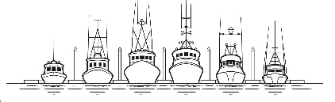  PETERSBURG BOROUGH  R.O.W. VACATION |  |  |  | CODE TO: |  |  | 110.000.404110
 |  |  |  | BASE FEE: |  |  | $50.00
 |  |  |  | PUBLIC NOTICE FEE: |  |  | $70.00
 |  |  |  | TOTAL: |  |  | $120.00
DATE RECEIVED: |  | RECEIVED BY: |  | CHECK NO. or CC:
APPLICANT/AGENT |  |  | PROPERTY OWNER(S)
NAME |  |  | NAME
MAILING ADDRESS |  |  | MAILING ADDRESS
CITY/STATE/ZIP |  |  | CITY/STATE/ZIP
PHONE |  |  | PHONE
EMAIL |  |  | EMAIL
Adjacent Properties
Number of Lots/Parcels Affected by Vacation: |  |  | Subdivision: |  | Plat #:
SUBMITTALS:
Please include a copy of plat.
SIGNATURE(S):
I (we) do hereby apply for a vacation of the borough owned easement/right-of-way/land in accordance with the provisions of Title 18, SUBDIVISIONS of the Petersburg Municipal Code.

I (we) am (are) the owners of the real estate which borders said borough-owned easement/right-of-way/and, which is generally described above.

Lot/Block | Owner(s) Name | Mailing Address |  | Email |  | Phone
Signature:
Signature:
Signature:
Signature:
Signature:

